Software Requirements Specification
Connect Directory Bot
Tapovan Sanskarpith Alumni Network — Verified Business & Professional Directory Bot

Document Version: 1.6 (Draft)
Prepared by: Dhrumil
Date: September 2026
Status: Implementation nearly complete — Deployment (Phase 7) remaining

Table of Contents
Table of Contents 2
1. Introduction 4
1.1 Purpose 4
1.2 Background 4
1.3 Motive and Core Philosophy 4
1.4 Scope 4
1.4.1 In Scope (Version 1) 4
1.4.2 Out of Scope (Version 1) 4
2. Overall Description 6
2.1 Product Perspective 6
2.2 Product Functions (Summary) 6
2.3 User Classes and Characteristics 6
2.4 Operating Environment 6
2.5 Design and Implementation Constraints 6
2.6 Assumptions and Dependencies 7
3. Stakeholders 8
4. Functional Requirements 9
FR-1: Query Handling 9
FR-2: Query Parsing 9
FR-3: Directory Search 9
FR-4: Response — Match Found 9
FR-5: Response — No Match Found 9
FR-6: Registration (External to Bot) 9
FR-7: Report Outdated Info 9
FR-8: Open Access 9
FR-9: Closed Directory Data 9
FR-10: Partial Match Handling (Location) 10
FR-11: Analytics Logging 10
5. Non-Functional Requirements 11
6. User Stories 12
7. Data Requirements — Directory Sheet Schema 13
7.1 Data Tab 13
7.2 Analytics Tab (FR-11) 13
8. Registration Google Form — Question List 15
Category Dropdown Options (Q3) 15
9. Hosting & Deployment Decision 16
Sufficiency Assessment 16
Constraints to Verify 16
Operational Recommendation 16
10. System Design 17
10.1 High-Level Architecture 17
10.2 Query Handling Flow 17
10.3 Module Breakdown 19
10.4 Deployment View 19
11. Implementation Plan 20
11.1 Tech Stack — Finalized 20
11.2 Build Phases 20
12. Assumptions 22
13. Constraints 22
14. Open Questions for Testing Phase 23

1. Introduction

1.1 Purpose
This document specifies the software requirements for a Telegram-based directory bot that replaces the manual, chat-based request-and-reply pattern currently used in a WhatsApp group (“Connect Group”) of Tapovan Sanskarpith alumni. The bot allows any user to send a free-text requirement (e.g., a need for a doctor, supplier, or service provider) and receive matching contact details drawn from a verified directory of registered group members.
This SRS follows a standard structure — introduction, overall description, stakeholders, functional and non-functional requirements, user stories, data requirements, and constraints — scoped appropriately for a solo/small-team project rather than a large enterprise system.

1.2 Background
The Connect Group is a WhatsApp community of Tapovan Sanskarpith (a Jain institute in Gandhinagar, Gujarat) alumni. It currently has approximately 1,024 members, of whom roughly 300 are active. On average, 30–40 requirement or inquiry messages are posted daily — requests such as references for doctors, suppliers, chartered accountants, interior designers, printers, and similar professional or business needs.
Today, members post these requirements as free-text messages in the group and wait for replies from other members. This process is slow, unsearchable, easily buried under unrelated chat activity, and offers no way to systematically query “who in this group does X.”

1.3 Motive and Core Philosophy
The founding motive of the Connect Group is to give business preference to fellow alumni before looking outside the network — summarized informally as “give business to our brothers first.” Trust in the network comes from shared institutional background (Tapovan Sanskarpith), not from open-market reputation systems (ratings, reviews, etc.).
This SRS treats that philosophy as a formal, non-negotiable constraint on the system: the bot's data source must remain a closed, verified directory of alumni — even though the bot itself is openly queryable by anyone (see Section 3).

1.4 Scope

1.4.1 In Scope (Version 1)
- A Telegram bot that accepts free-text requirement queries from any user and returns matching contacts from a verified alumni directory.
- A Google Form through which alumni members register their business/profession into the directory.
- A Google Sheet acting as the directory's data store.
- A second Google Form, linked (pre-filled per entry) in every bot response, for reporting outdated or incorrect contact information.
- LLM-based parsing of free-text queries into structured search terms (category, sub-category/tags, location).

1.4.2 Out of Scope (Version 1)
- In-bot self-registration — registration happens only via the Google Form.
- DM-based confirmation from a matched member before their contact info is shared with the requester.
- Any authentication, login, or access restriction on who may query the bot.
- Migrating or replacing the WhatsApp group itself — the group continues to operate in parallel.
- Payments, transactions, ratings, or review features.

2. Overall Description

2.1 Product Perspective
The bot is a standalone companion tool to the existing WhatsApp Connect Group — it does not replace or integrate with WhatsApp directly (no official bot API exists for personal WhatsApp groups). Instead, it operates on Telegram, a platform with first-class, free bot support, and draws its directory data from a Google Sheet maintained via Google Forms.

2.2 Product Functions (Summary)
- Accept a free-text requirement query from a Telegram user.
- Parse the query into structured search terms using an LLM.
- Search the directory (Google Sheet) for matching entries.
- Reply directly with full contact details for all matches, each with a pre-filled “report outdated info” link.
- Reply with a fixed “not found” message when no match exists.

2.3 User Classes and Characteristics
User Class | Characteristics
Registrants (alumni members) | Tapovan Sanskarpith alumni who run a business or profession and choose to register via the Google Form. Generally well-established professionally; register voluntarily.
Querying users | Any Telegram user, member or non-member of the WhatsApp group. No technical expertise assumed — interacts via plain-language chat messages only.
Admin (Dhrumil) | Owns and maintains the directory Sheet, bot logic, and hosting. Reviews outdated-info reports and updates records.

2.4 Operating Environment
- Client: Telegram app (mobile/desktop/web) — no separate app installation required for end users.
- Backend: Bot logic hosted on a free/low-cost hosting service (final choice pending — see Design phase).
- Data store: Google Sheets, accessed via the Google Sheets API.
- NLP: A hosted LLM API (e.g., Groq or Google Gemini free tier) used only for query parsing.

2.5 Design and Implementation Constraints
- No official WhatsApp bot API is available for personal/group use — hence Telegram is used as the query interface instead of WhatsApp.
- Directory quality depends entirely on voluntary, self-reported registration — there is no independent verification step in v1.
- Google Sheets has practical scale limits (row count, API read/write quotas) — acceptable at current volumes (~300 active members, 30–40 daily queries) but a future migration path (e.g., to a proper database) should be kept in mind.

2.6 Assumptions and Dependencies
- Members are willing to self-register via a Google Form; no bulk/automated onboarding exists for v1.
- Users are willing to separately open Telegram to query the bot, even though the source community is on WhatsApp.
- LLM-based query parsing is “good enough” for matching; perfect accuracy is not required for v1.
- Dhrumil is the sole content moderator/admin; no multi-admin workflow is required at this stage.

3. Stakeholders
Stakeholder | Description | Relationship to System
Group members (registrants) | ~1,024 Tapovan Sanskarpith alumni, ~300 active in the WhatsApp group. | Voluntarily register their business/profession via the Google Form. Their data forms the entire directory.
Querying users | Anyone who messages the bot on Telegram. | Can be a group member or a non-member — access is open, with no restriction. Receives contact info directly when a match is found.
Admin (Dhrumil) | System owner and maintainer. | Manages the Sheet, reviews reported outdated info, maintains the bot and its hosting.
Note: a single individual may be both a registrant and a querying user. Non-group-members are permitted to query the bot but can never appear as directory entries themselves — directory data originates solely from the verified registration Form.

4. Functional Requirements

FR-1: Query Handling
The system shall accept a free-text message from any Telegram user (no login or authentication required) describing a requirement — for example, “Need a knee replacement surgeon in Ahmedabad.”

FR-2: Query Parsing
The system shall use an LLM to extract structured fields from the free-text query:
- category (e.g., Medical, Printing, CA/Finance, Interior Design)
- sub-category / tags (e.g., Orthopedic, Knee Surgery)
- location (if mentioned)

FR-3: Directory Search
The system shall search the Google Sheet directory using the parsed fields and return all matching entries.

FR-4: Response — Match Found
If one or more matches are found, the bot shall reply directly with full contact details (name, phone number, business/profession, and full address with a clickable Google Maps link) for each match. No intermediate confirmation step or DM to the matched member is required before sharing their contact.

FR-5: Response — No Match Found
If no match is found, the bot shall reply with the following fixed message:
“Data not found. Please put the same query in the WhatsApp group.”

FR-6: Registration (External to Bot)
Directory entries are added only via a Google Form. The bot itself does not accept new registrations through chat.

FR-7: Report Outdated Info
Every matched entry in a bot response shall include a link to a second Google Form where users can report outdated or incorrect information for that entry. The link shall be pre-filled (via Google Forms' pre-filled URL feature) with the entry's identifying details (e.g., name/business), so the reporter does not need to manually re-type which entry they are reporting.

FR-8: Open Access
The bot shall not restrict who can send it a query. Any Telegram user — member or non-member of the WhatsApp group — can use it.

FR-9: Closed Directory Data
Regardless of who queries the bot, returned contacts shall only ever be sourced from the registered alumni directory (Google Sheet) — never from any external or general-purpose source.

FR-10: Partial Match Handling (Location)
If an entry matches a query's category and/or sub-category tags but not its location, the system shall still include that entry in the response rather than excluding it, with a note reflecting the entry's declared Service Area:
- If Service Area is “Pan-India” or covers the query's region, the note shall indicate the business serves that area (not a mismatch warning).
- If Service Area is “No, local only” and the location does not match, the note shall read: “⚠️ Registered in <Address> — confirm before reaching out.”

FR-11: Analytics Logging
Every user query shall be logged: the raw query text, the LLM-parsed category/tags/location, and a summary of the matched results (or the no-match outcome), appended as a new row to the Analytics tab of the Directory Google Sheet. This applies whether or not a match was found, and is for admin monitoring only — it is never shown to end users.

5. Non-Functional Requirements
ID | Requirement
NFR-1 (Performance) | The bot should reply within a few seconds of a query, given expected volume (~30–40 queries/day currently, with headroom for growth as adoption increases across 1,024 members).
NFR-2 (Availability) | The bot should be available 24/7 — reasonable uptime for a free-tier/self-hosted small project, not enterprise-grade SLAs.
NFR-3 (Privacy) | Directory data (name, phone, business info) is collected only with explicit consent via the registration Form; registrants are informed that their info will be shared with anyone who queries the bot.
NFR-4 (Scalability) | The system should comfortably handle current load (~30–40 queries/day, up to ~300 active members) without redesign; Google Sheets as a data store is acceptable at this scale.
NFR-5 (Maintainability) | The admin should be able to manually correct or update Sheet entries without needing to touch bot code.
NFR-6 (Cost) | The system should run on free-tier services (Telegram Bot API, Google Sheets API, free-tier LLM API), given this is a non-commercial community project.

6. User Stories
- As a group member, I want to message the bot with my requirement in plain language, so that I can quickly find a trusted alumni contact without waiting for replies in the group.
- As a group member, I want the bot to show me contact details directly, so that I can reach out immediately without extra steps.
- As a business-owning alumni member, I want to register my business once via a form, so that I become discoverable to anyone searching the bot.
- As any user (member or not), I want to be able to query the bot freely, so that access isn't gated behind group-membership verification.
- As an admin, I want a way for users to flag outdated contact info, so that the directory stays accurate over time.
- As an admin, I want all directory data to come only from the registration form, so that the trust and quality bar of “verified alumni” is maintained.

7. Data Requirements — Directory Sheet Schema
The Directory Google Sheet has two tabs: a Data tab (the directory itself, mirroring the registration Form) and an Analytics tab (query logs, for admin monitoring only).

7.1 Data Tab
Mirrors the registration Google Form field-for-field, plus two admin-managed columns for review workflow. Finalized schema:
Column | Source | Purpose / Notes
Timestamp | Auto (Form) | Record-keeping.
Name | Form Q1 | Registrant's full name.
Phone Number | Form Q2 | Primary contact number.
Category | Form Q3 | Fixed dropdown value — primary filter for matching.
Sub-category / Tags | Form Q4 | Freeform comma-separated keywords — used for LLM/keyword matching.
Business Name | Form Q5 | Optional.
Address | Form Q6 | Full address of the business (used in FR-4 replies and FR-10 notes).
Google Maps Link | Form Q6.5 | Valid https://maps.app.goo.gl link, submitted by the registrant; makes the address clickable in bot replies.
Service Area | Form Q7 | Local only / Regional / Pan-India — drives partial-match note logic (see FR-10).
Notes | Form Q8 | Optional additional information.
Consent | Form Q9 | Always “Yes” (required field on the Form).
Status | Admin-managed | Active / Reported Outdated — set manually after verifying a report.
Last Updated | Admin-managed | Date the admin last verified/edited the entry.

7.2 Analytics Tab (FR-11)
Logged automatically by the bot for every incoming query, regardless of outcome. Never shown to end users — admin monitoring only.
Column | Purpose / Notes
Timestamp | When the query was received.
Username | The name of the user who does query.
Raw Query | The user's original free-text message, unmodified.
Category | Category extracted by the LLM Parser.
Tags | Sub-category tags extracted by the LLM Parser.
Location | The location entered by user, extracted by the LLM Parser.
Matched Count | Number of entries returned (0 if no match — see FR-5).

8. Registration Google Form — Question List
The following questions constitute the registration Form through which alumni members are added to the directory.
# | Question | Type | Required
1 | Full Name | Short answer | Yes
2 | Contact Number (WhatsApp/Mobile) | Short answer | Yes
3 | Business/Profession Category | Dropdown (fixed list + “Other”) | Yes
4 | Specific Service / Sub-category (comma-separated keywords) | Short answer | Yes
5 | Business/Firm Name | Short answer | No
6 | Full Address | Short answer | Yes
6.5 | Google Maps Link (share/copy link from the Google Maps app) | Short answer | Yes
7 | Do you serve outside your city? | Multiple choice: No, local only / Yes, nearby region / Yes, Pan-India | Yes
8 | Additional Notes (hours, website, specialties) | Paragraph | No
9 | Consent to share info via the bot | Checkbox | Yes

Category Dropdown Options (Q3)
Medical & Healthcare; Legal; CA/Finance & Accounting; Education & Tutoring; Interior Design/Architecture; Printing & Stationery; Event Management; Real Estate; Retail/Trading; Food & Catering; Transport/Logistics; Home Services (Electrician, Plumber, etc.); IT/Technology; Other.
Design rationale: Q3 (fixed dropdown) keeps categories consistent for filtering; Q4 (freeform) gives the LLM specific keywords for nuanced matching (e.g., “knee surgeon”) without forcing every possible specialty into a rigid taxonomy.

9. Hosting & Deployment Decision
The bot backend will be hosted on Google Cloud Platform's Always Free e2-micro tier (1 shared vCPU, 1GB RAM, 30GB storage) — an existing account already available to the admin.

Sufficiency Assessment
- A Node.js Telegram bot performing text-based request/response with occasional external API calls (Google Sheets, LLM) typically uses well under 200MB RAM under normal load.
- Expected volume (~30–40 queries/day) is very low — the free-tier resources are expected to be comfortably sufficient with significant headroom for growth.
- 30GB storage far exceeds requirements for application code and logs.

Constraints to Verify
- Confirmed: the existing GCP Compute Engine VM is deployed in us-west1, which is within the Always Free e2-micro eligible regions (us-west1 / us-central1 / us-east1) — no billing risk from region mismatch.
- Expect an additional ~200–300ms network latency (server in the US, users in India) — negligible for a chat bot replying within a few seconds.

Operational Recommendation
- Run the bot process under a process manager (e.g., pm2) so it auto-restarts on crash, rather than requiring manual SSH intervention.
Alternative considered: Google Cloud Run (serverless, scales to zero, no OS maintenance) would also fit this workload but requires a webhook-based bot instead of long-polling. Given the existing free-tier VM and familiarity with a traditional server model, the Compute Engine approach above is the confirmed choice for v1.

10. System Design

10.1 High-Level Architecture
The system is composed of five cooperating pieces: the Telegram client (user-facing), the Telegram Bot API, the Node.js backend (hosted on the GCP e2-micro VM), an LLM API used only for query parsing, and the Google Sheets API/Directory Sheet (Data tab + Analytics tab) as the single source of truth. Registration and outdated-info reporting flow into the Data tab through separate, simpler paths (a direct Form-to-Sheet append, and an admin-mediated manual update, respectively); every query — matched or not — is separately logged to the Analytics tab (FR-11).
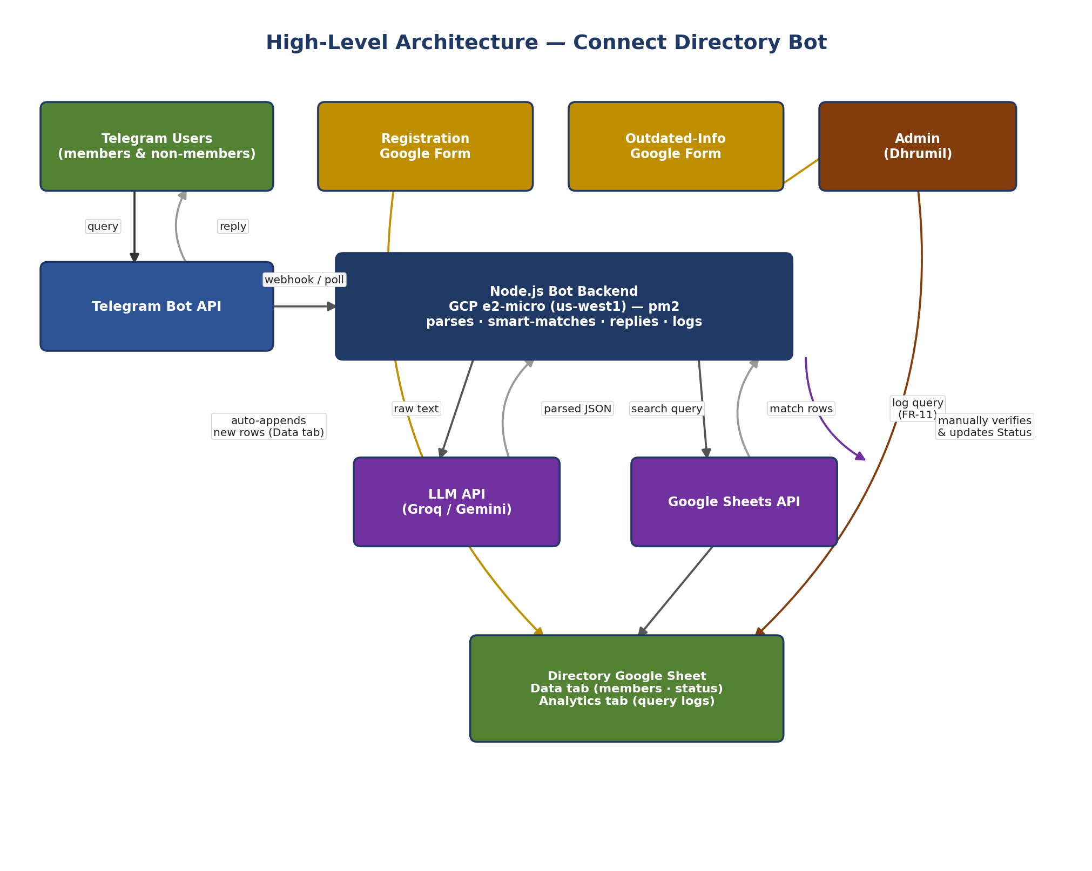
Figure 1 — High-level system architecture

10.2 Query Handling Flow
The diagram below traces a single query end-to-end: from the user's free-text message, through LLM parsing and smart directory search, to the two possible outcomes (no match vs. one or more matches, with or without a location note per FR-10). Every query is logged to the Analytics tab regardless of outcome (FR-11).
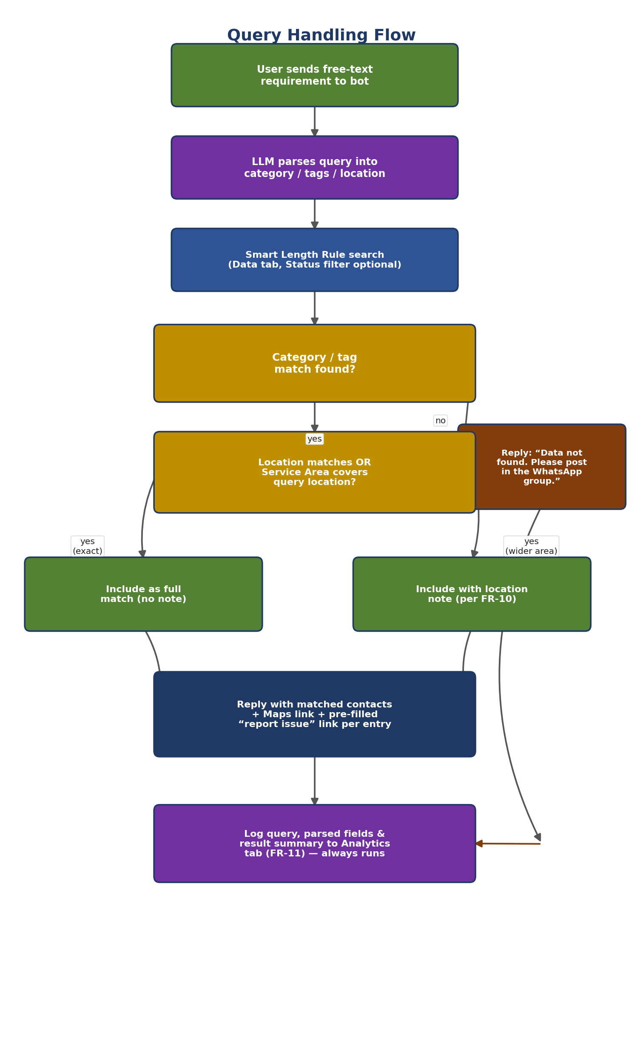
Figure 2 — Query handling flow, including FR-10 partial-match branching and FR-11 analytics logging

10.3 Module Breakdown
Module | Responsibility
Telegram Listener | Receives incoming messages from the Telegram Bot API (via webhook or long-polling) and forwards the raw text to the Query Handler.
Query Handler | Orchestrates the flow: calls the LLM Parser, calls the Directory Search module, applies FR-10 logic, triggers the Analytics Logger, and formats the final reply.
LLM Parser | Sends the raw query text to the LLM API (Groq/Gemini) with a fixed extraction prompt; returns structured {category, tags, location}.
Directory Search | Reads the Directory Sheet's Data tab (via Sheets API); optionally filters by Status = Active; smart-matches against category/tags/location using a length-aware rule (see Section 11.2, Phase 4) to avoid false positives like “CA” matching inside “Medical.”
Reply Formatter | Builds the outgoing Telegram message: contact details, a clickable Google Maps link, and a pre-filled “report issue” link per matched entry (FR-4, FR-7).
Report Link Builder | Generates the pre-filled Google Form URL for each entry using its identifying fields (Name/Business).
Analytics Logger | Appends the raw query, parsed fields, and matched-result summary to the Analytics tab for every query, matched or not (FR-11).

10.4 Deployment View
- Runtime: Node.js process on the existing GCP Compute Engine e2-micro VM (us-west1, Always Free tier).
- Process management: pm2, configured to auto-restart the bot on crash or VM reboot.
- Configuration: API keys/tokens (Telegram Bot Token, LLM API key, Google service account credentials) stored as environment variables, not committed to source control.
- Logging: application logs written locally on the VM (well within the 30GB free-tier storage) for debugging and basic usage tracking.

11. Implementation Plan
The build is broken into sequential phases, each with a clear exit criterion before moving to the next. Phases 1–5 can be developed and tested locally (bot polling from a developer machine); Phase 7 moves the finished, tested bot onto the GCP VM for 24/7 operation.

11.1 Tech Stack — Finalized
Layer | Choice
Runtime | Node.js
Telegram integration | Telegraf (or node-telegram-bot-api)
Directory data access | googleapis (Google Sheets API v4)
LLM query parsing | Groq API or Google Gemini API (free tier)
Process management | pm2
Hosting | GCP Compute Engine e2-micro, us-west1 (Always Free)
Config/secrets | .env file (not committed) via dotenv

11.2 Build Phases
Phase | Goal & Key Tasks | Exit Criteria
0 — Setup | Create Telegram bot via BotFather (get token). Create Registration & Outdated-Info Google Forms. Create Directory Google Sheet with the Section 7 schema. Set up a Google Cloud service account for Sheets API access. Obtain LLM API key (Groq/Gemini). Verify GCP VM (us-west1) is accessible. | All credentials/accounts exist; Sheet has correct columns (even if empty); bot responds to a basic BotFather test message.
1 — Telegram Bot Skeleton | Initialize Node.js project. Install Telegraf. Implement a basic listener that echoes back any message it receives (Telegram Listener module). | Bot runs locally and echoes any message sent to it on Telegram.
2 — Sheets Integration (Read) | Install googleapis, authenticate with the service account. Implement a function to read all rows from the Directory Sheet (Directory Search module, read-only for now). | On a test command, the bot logs/prints all current directory rows correctly.
3 — LLM Query Parsing | Integrate the chosen LLM API. Write and iterate on the extraction prompt (category / sub-category-tags / location as JSON) (LLM Parser module). | For 8–10 varied sample queries, the parser reliably returns correct structured JSON.
4 — Matching Logic + FR-10 | Implement the Smart Length Rule for Category/Tags matching: strict word-boundary matching for short tags, more flexible substring matching for long tags — prevents false positives (e.g., “CA” wrongly matching inside “Medical”). Implement the Location / Service Area branching per FR-10 (full match vs. match-with-note, never excluded). Handle the no-match case. | Against a small test dataset, correct entries are returned for exact matches, wider-service-area matches, and true no-matches — with no accidental subset matches.
5 — Reply Formatting + Analytics + Report Links | Format the outgoing Telegram message per FR-4 (full contact details + clickable Google Maps link) and FR-7 (pre-filled “report issue” link per entry). Implement the Analytics Logger to append every query — matched or not — to the Analytics tab (FR-11) (Reply Formatter + Report Link Builder + Analytics Logger modules). | Bot sends a complete, correctly formatted reply (with working Maps link and report link) for both match and no-match cases; every query is confirmed logged to the Analytics tab.
6 — End-to-End Local Testing | Populate the Sheet with an initial real (or realistic test) dataset. Run through edge cases: empty query, category-only query, gibberish input, exact-location match, partial-location match, no match at all. | All of FR-1 through FR-10 verified manually against a checklist; no crashes on malformed input.
7 — Deployment to GCP | Set up Node.js on the e2-micro VM (us-west1). Deploy the project, configure environment variables. Set up pm2 with a startup script so the bot survives VM reboots. | Bot is live 24/7 via Telegram, independent of any developer machine; verified to survive a VM restart.
8 — Soft Launch | Share the bot's Telegram username with the WhatsApp Connect Group. Monitor logs for errors as real registrations and queries come in. | Bot is publicly usable; first real registrations and queries are flowing in without critical errors.

12. Assumptions
- Members are willing to self-register via a Google Form; no bulk/automated onboarding is required for v1.
- Telegram is an acceptable platform even though the source group is on WhatsApp — users are expected to separately open Telegram to use the bot.
- LLM-based parsing is “good enough” for matching in v1 — perfect accuracy is not required.
- The admin (Dhrumil) is the sole content moderator; no multi-admin workflow is required.

13. Constraints
- No official WhatsApp bot capability exists for personal groups — hence the move to Telegram as the query interface.
- The data store (Google Sheets) has practical row/read limits at very large scale, though this is not a concern at current volumes.
- Directory quality depends entirely on voluntary, accurate self-registration — there is no independent verification step in v1.
- GCP hosting is confirmed on the Always Free e2-micro tier in us-west1 — within the eligible region set.

14. Open Questions for Testing Phase
The following items from previous drafts are now resolved:
- Partial match handling — resolved, see FR-10 and Section 10.2 (flow diagram).
- Sheet schema and category taxonomy — resolved, see Sections 7 and 8 (now includes Address, Google Maps Link, and the Analytics tab).
- Hosting choice and deployment region — resolved and confirmed: GCP e2-micro, us-west1, within the Always Free tier.
- Outdated-info review workflow — resolved: pre-filled report Form linked at the end of every bot message; admin manually verifies and updates Status before changing the record.
- Periodic re-verification — resolved for v1: not included. The directory remains purely report-driven; a scheduled re-verification ping is deferred as a possible v2 enhancement.
- System architecture and module breakdown — resolved, see Section 10 (now includes the Analytics Logger module).
- Build sequence and tech stack — resolved, see Section 11 (Implementation Plan).
- Category/tag matching algorithm — resolved: the Smart Length Rule (Section 11.2, Phase 4), implemented and locally tested.
- Analytics logging (FR-11) — resolved and implemented: every query is logged to the Analytics tab regardless of outcome.
Remaining open items:
- Deployment to the GCP e2-micro VM (Phase 7) — the one phase not yet complete as of this revision. pm2 startup-script behavior across a VM reboot should be explicitly verified once deployed.
- Soft Launch (Phase 8) — sharing the bot with the WhatsApp Connect Group and monitoring early real-world usage.

This document will evolve through subsequent SDLC phases: Testing Plan and Deployment.

